**Motorized Needle Driver**

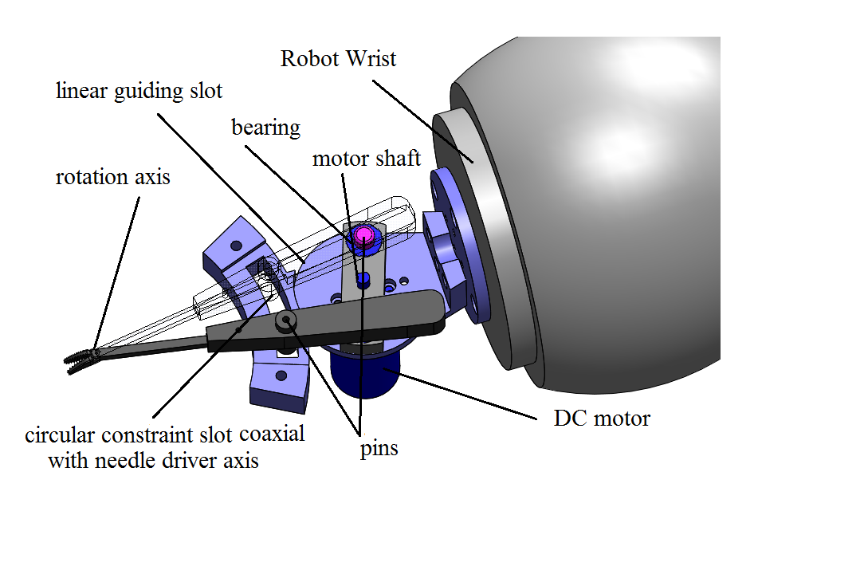

Fig.1. Motorized Needle driver.

The motorized needle driver mounted on the robot is shown as Fig.1. This device incorporates a [Mayo Hager needle holder](http://www.medical-tools.com/shop/mayo-hager-fine-needle-holder.html) and the motorized mechanism for driving it. The design projective is that the needle driver can be controlled without mounting a motor directly on its rotation axis, which may impede the needle driver approaching the sewn object in some direction. This design features two set of constraints/guiding slots working in conjunction with pins. The linear slot lies in the direction along the handle of the needle driver and the constraint slot is coaxial with the needle driver axis; therefore the motor rotation can be mapped to the open and close of the needle driver. To reduce frictions in driving this mechanism, bears are used. One feature of this design is that the two jaws of the needle driver work in an unsynchronized way. In the situation that the needle driver is not fully open, the center line of the grasper is located near one jaw which may create difficulty in approaching a target point and grasp precisely. One method to solve this disadvantage is to replace the linear guiding slot with slot with a critical geometry.